Turn in a flowchart and the pseudo code for each of the problems

1) Redraw the following flowchart to make it structured and also write the pseudo code for the structured flowchart

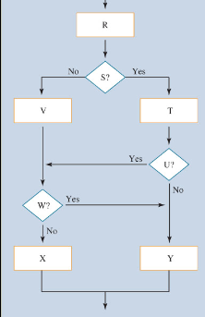

2) The indentation for the following pseudo code is all messed up. Fix it and then draw the flowchart for it

if A is true then
do B
if C is true
do D
endif
do E
if F is true then
do H
else
do G
if y is true then
do k
endif
endif
else
if I is true then
do J
else
do K
do L
do M
endif
endif
do N

